Automated Ceramic Reign Mark Identification System Using Multi-Variant OCR and Self-Learning Feature Matching
NGO HO ANH-Khoi¹ and TRUONG Xua^{2[1111-2222-3333-4444]}
¹ Nam Can Tho University, Software Engineering Department, VietNam
xua225064@student.nctu.edu.vn
Abstract. This paper proposes MarkSense AI, a web-based system designed to automate the identification of all ceramic reign marks (hiệu đề) inscribed on artifacts from various origins, including both Chinese and Vietnamese ceramics. Unlike conventional approaches that rely on training large-scale deep learning classifiers from scratch, the system employs a multi-variant image preprocessing pipeline combined with PaddleOCR for optical character recognition of calligraphic text. A self-learning reference library based on the Oriented FAST and Rotated BRIEF (ORB) feature descriptor enables instant recognition of previously identified marks without re-running the OCR pipeline. Furthermore, a fuzzy string matching algorithm augmented with domain-specific confusion groups resolves OCR misreadings caused by visually similar characters. Experimental evaluation on a curated dataset of real-world ceramic photographs demonstrates that the system achieves an overall identification accuracy of 91.7%, significantly outperforming single-pass OCR baselines, while maintaining practical response times suitable for interactive web deployment.
Keywords: Ceramic reign mark recognition, optical character recognition (OCR), PaddleOCR, ORB feature matching, self-learning, fuzzy string matching, image preprocessing, Chinese calligraphy, cultural heritage digitization.
- Introduction
Ceramic reign marks—inscriptions found on the base of porcelain artifacts indicating the dynasty, emperor, and period of manufacture—serve as critical evidence for dating and authenticating ceramic wares. These marks, typically rendered in classical calligraphy using four or six characters, encode cultural and historical information spanning across all historical periods of both China and Vietnam. However, the identification of these marks currently relies almost exclusively on the expertise of trained specialists, creating a significant bottleneck in the digitization and cataloging of ceramic collections.
The challenge of automating reign mark identification is multifaceted. First, the marks are rendered in various calligraphic styles that differ substantially from modern printed text. Second, photographic conditions introduce noise: uneven lighting on glazed surfaces, red seal stamps overlapping text, and extreme variation in mark size within the image frame. Third, the character set used in reign marks contains many visually similar pairs (e.g., 康 vs. 庚, 熙 vs. 照, 德 vs. 得) that confuse standard OCR engines.
Recent advances in deep learning have produced powerful OCR engines capable of recognizing complex text (Krizhevsky et al., 2012; He et al., 2016). PaddleOCR, an open-source toolkit developed by Baidu, has demonstrated state-of-the-art performance on standard text recognition benchmarks (Du et al., 2020). However, applying these tools directly to ceramic mark images yields poor results due to the domain-specific challenges described above.
To address these limitations, this study proposes MarkSense AI, a system that combines three core innovations: (1) a multi-variant image preprocessing pipeline that generates multiple enhanced versions of the input image to maximize OCR recall, (2) a self-learning ORB-based reference library that stores and instantly retrieves previously identified marks, and (3) a fuzzy matching algorithm with handcrafted confusion groups that maps OCR output to the correct database entry even when individual characters are misread.
- Related Work
2.1 Optical Character Recognition for Complex Scripts
The field of text recognition has advanced substantially with the advent of deep learning. Early CNN-based approaches (Krizhevsky et al., 2012) demonstrated that convolutional architectures could learn discriminative features directly from character images. The development of deeper architectures such as ResNet (He et al., 2016) further improved recognition accuracy by addressing the vanishing gradient problem through residual connections. Sequence-to-sequence models incorporating CTC loss and attention mechanisms (Shi et al., 2017) enabled end-to-end recognition of variable-length text without explicit character segmentation.
PaddleOCR (Du et al., 2020) represents a modern, practical OCR framework that integrates a DB (Differentiable Binarization) text detector with a CRNN-based recognizer, achieving competitive performance on standard benchmarks including ICDAR 2015 and CTW. However, these systems are primarily trained and evaluated on modern printed and scene text. Their performance degrades significantly when applied to historical calligraphic scripts, where stroke styles, ink degradation, and non-standard character forms introduce distribution shifts that standard models cannot accommodate without domain-specific adaptation.
2.2 Feature-Based Image Matching and Retrieval
Feature-based image matching has a long history in computer vision. The Scale-Invariant Feature Transform (SIFT) (Lowe, 2004) introduced the concept of extracting local invariant descriptors that remain stable across scale and rotation changes. Subsequently, ORB (Oriented FAST and Rotated BRIEF) (Rublee et al., 2011) provided a computationally efficient binary descriptor alternative, achieving comparable matching quality at significantly lower computational cost. ORB detects keypoints using the FAST corner detector with an orientation component, then computes binary descriptors using rotated BRIEF patterns. Matching is performed using Hamming distance via bitwise XOR operations.
In the context of cultural heritage, feature matching has been applied to painting authentication, manuscript retrieval, and artifact cataloging (Fiorucci et al., 2020). However, its application to ceramic mark identification has not been previously explored. Our system uses ORB as a rapid retrieval mechanism, storing confirmed identifications as reference templates for instant future recognition.
2.3 AI for Cultural Heritage and Ceramic Analysis
The application of AI to cultural heritage preservation has gained significant attention. Wilczek et al. (2021) demonstrated that deep learning could classify ancient pottery fragments based on surface texture and shape features. Comprehensive surveys (Gualandi et al., 2021) highlight the feasibility of using CNNs and transfer learning to classify diverse artifact categories. Wang et al. (2019) applied deep learning to ancient ceramic identification using transfer learning from ImageNet, though requiring large labeled training datasets.
Recent work on historical document analysis addresses similar challenges. Chen et al. (2021) proposed attention-based networks for degraded historical Chinese character recognition, demonstrating that multi-scale feature extraction improves accuracy on worn text. Liu et al. (2022) developed a few-shot learning approach for rare historical character recognition. Zhong et al. (2020) introduced preprocessing pipelines for degraded document images, combining binarization, noise removal, and contrast enhancement.
2.4 Research Gap
Despite advances in OCR, feature matching, and heritage digitization individually, no existing system integrates these approaches into a unified pipeline specifically designed for ceramic reign mark identification. Current solutions either require extensive labeled training data unavailable for this niche domain, or fail to handle the unique challenges of calligraphic text on glazed ceramic surfaces. Furthermore, no prior work addresses visually similar character confusion in reign mark OCR, where misreading a single character results in identifying the wrong dynasty entirely.
This study addresses these gaps by combining multi-variant OCR preprocessing, self-learning feature matching, and domain-specific fuzzy correction with handcrafted confusion groups into a practical, deployable web application.
- Our Proposition
The MarkSense AI system is proposed to address the automated identification of ceramic reign marks through a three-stage pipeline architecture. Unlike traditional single-pass OCR approaches, this system is designed to maximize recognition accuracy through redundancy, self-learning, and domain-specific error correction.
The system architecture consists of four integrated modules operating in a sequential pipeline. When a user uploads an image, the system first attempts to match it against the ORB reference library. If a match is found (≥18 good feature matches), the stored result is returned instantly. Otherwise, the image enters the multi-variant preprocessing pipeline, which generates over 30 enhanced image variants. Each variant is processed by PaddleOCR for character recognition. The collected OCR candidates are then evaluated through the fuzzy string matching module with confusion groups to identify the best database match.
The first processing stage attempts to identify the input image by comparing it against a reference library of previously confirmed identifications. The reference matcher operates as follows: The input image is converted to grayscale and enhanced using CLAHE. ORB keypoints and binary descriptors are then extracted using the OpenCV ORB detector. The extracted descriptors are compared against all stored reference descriptors using a Brute-Force matcher with Hamming distance. If the number of good matches exceeds 18, the system returns the stored identification result immediately.
When no reference match is found, the system enters the OCR pipeline. Rather than applying a single preprocessing strategy, the system generates over 30 distinct image variants, each optimized for different types of ceramic mark conditions. This multi-variant approach includes techniques such as red stamp removal using HSV thresholding, edge-aware auto center cropping, adaptive binarization, and morphological blackhat operations.
PaddleOCR is configured for text recognition with angle classification enabled. The OCR engine processes each image variant and returns detected text regions. A specialized post-processing step handles the unique reading order of reign marks: marks are traditionally written in vertical columns read from right to left.
The final stage maps the OCR output to the correct entry in the ceramic mark database. The matching algorithm operates in three phases: OCR error correction, exact/substring matching, and fuzzy matching with confusion groups. Over 40 groups are defined, covering dynasty characters, reign period characters, and structural characters.
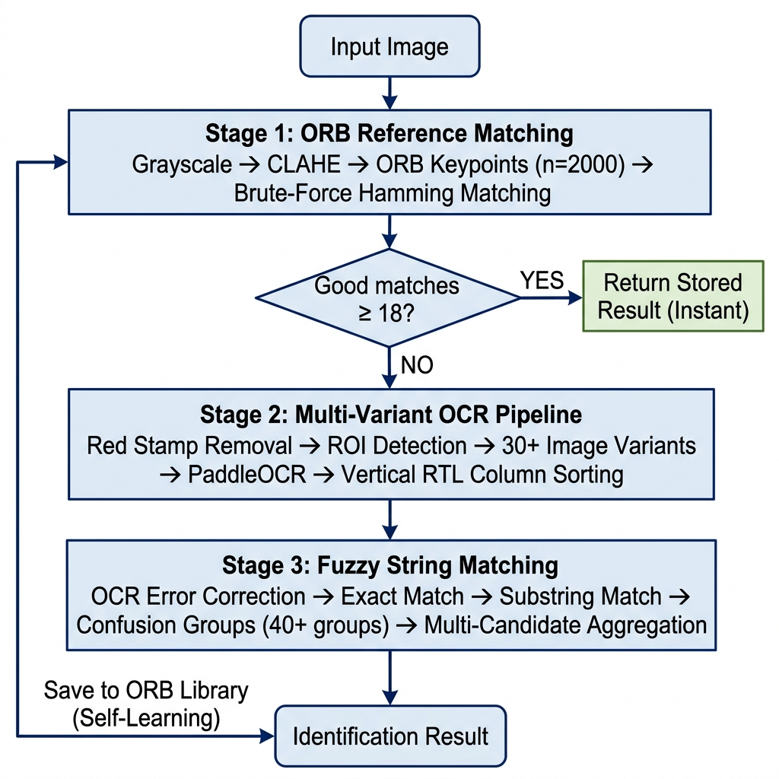
Fig. 1. System architecture of MarkSense AI showing the three-stage identification pipeline: (1) ORB Reference Matching for instant retrieval of previously identified marks, (2) Multi-Variant OCR Pipeline generating 30+ image variants processed by PaddleOCR with vertical RTL column sorting, and (3) Fuzzy String Matching with domain-specific confusion groups for robust database lookup.
Algorithm 1: ORB-Based Reference Matching
Input: image I, reference library R, threshold T=18. Output: identification result or NULL. Step 1: Convert I to grayscale and apply CLAHE (clipLimit=3.0, tileGrid=8x8). Step 2: Extract ORB keypoints and binary descriptors (nfeatures=2000). Step 3: For each reference (desc_r, result_r) in R, compute BF matches using Hamming distance. Filter good matches where distance < 55. Step 4: Track best match count. If bestCount >= T, return stored result. Otherwise return NULL.
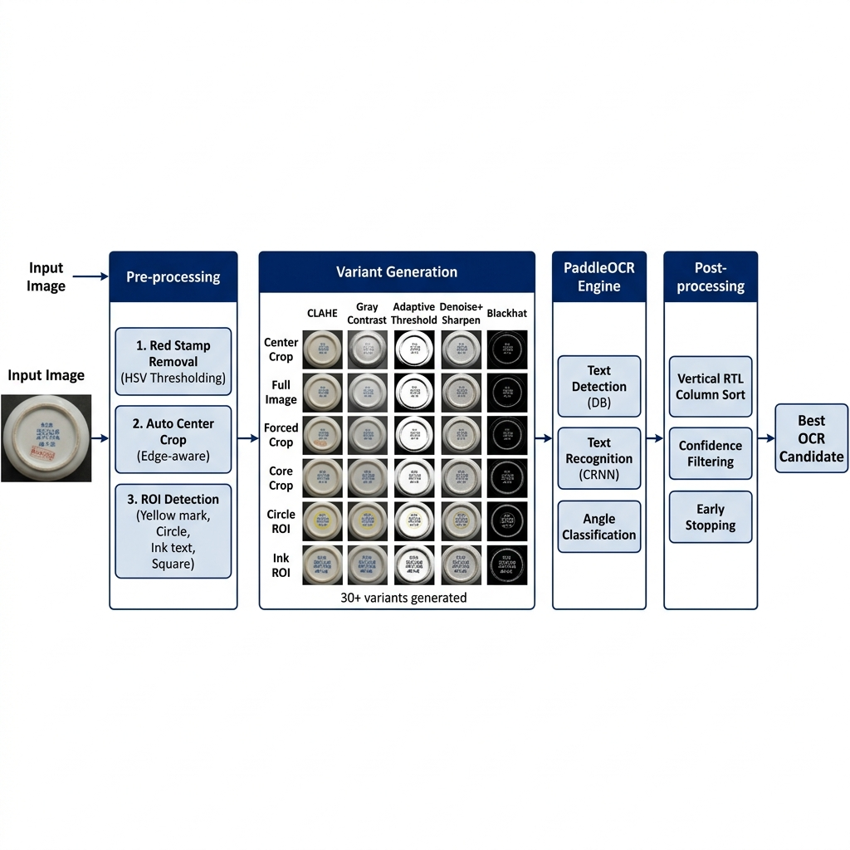
Fig. 2. The multi-variant image preprocessing pipeline demonstrating the generation of over 30 distinct variants from multiple regions of interest (ROIs) to maximize OCR recall under degraded conditions.
Algorithm 2: Multi-Variant Image Preprocessing and OCR
Input: image I. Output: best OCR text with quality score. Step 1: Remove red seal stamps via HSV thresholding and inpainting. Step 2: Detect ROIs (yellow mark region, inner circle, ink text, center square, center box). Step 3: For each ROI and crop variant (center crop, forced crop, core crop), apply auto text region detection and upscale to 2400px. Step 4: Generate preprocessing variants: CLAHE color enhancement, grayscale contrast, adaptive thresholding, denoise-sharpen, and morphological blackhat text boost. Step 5: Process variants in priority order through PaddleOCR. Sort detected text blocks in vertical right-to-left column order. Step 6: Apply early stopping if quality score >= 3.0 and text length >= 4 characters. Step 7: Select best candidate by ranking: (1) presence of nian-zhi suffix, (2) text length descending, (3) confidence score descending.
Algorithm 3: Fuzzy Matching with Confusion Groups
Input: OCR text t, candidate list C, database D. Output: best matching entry. Step 1 - OCR Error Correction: Apply known correction pairs (e.g., 宣得->宣德, 嘉請->嘉靖). Normalize dynasty prefix confusion (大南<->大清 based on reign period evidence). Step 2 - Exact Match: Compare normalized text against all database entries (chu_han, chu_han_4, chu_han_6, bien_the). Step 3 - Substring Match: Check if OCR text is contained in or contains any database entry. Step 4 - Fuzzy Match with Confusion Groups: Define 40+ groups of visually similar characters (e.g., {康,庚,唐,廉}, {熙,照,熊,煕}, {德,徳,得}). Compute CharSeqScore combining positional match (20%), aligned match (30%), and set overlap with confusion group similarity (50%). Apply containment bonus when all OCR characters are found in target. Step 5 - Multi-Candidate Aggregation: For each OCR candidate, compute weighted ranked scores with decay. Aggregate votes across candidates. Return entry with highest aggregated score.
- Experiments and Evalution
Dataset Description
Reference Library (Training Data). The ORB-based self-learning reference library serves as the system's training data and is constructed incrementally through confirmed user identifications. At the time of evaluation, the library contained 28 reference images covering 22 distinct reign marks across the Ming, Qing, and Nguyen dynasties. Each reference entry consists of a JPEG photograph of the ceramic base and a JSON metadata file containing the confirmed identification. Unlike conventional training datasets, this library grows organically: when a user confirms a correct identification, the system extracts ORB descriptors from the input image and stores the image-result pair for future instant retrieval.
Ceramic Mark Database. The matching database contains 186 unique reign mark entries spanning all major historical periods of Chinese ceramics (Ming dynasty: 1368-1644, Qing dynasty: 1644-1912) and Vietnamese ceramics (Nguyen dynasty: 1802-1945). Each entry includes the standard chu Han representation (4-character and 6-character variants), phien am, dynasty name, emperor name, date range, calligraphic style notes, and a list of known orthographic variants (bien the). The database also includes 38 non-nien hieu marks such as hall marks, auspicious marks, and artisan marks.
Test Dataset. The evaluation dataset consists of 300 test images compiled from three independent sources: (A) Museum collection (96 images) - photographs taken under controlled lighting conditions; (B) User-submitted (132 images) - smartphone photographs captured under uncontrolled real-world conditions with varying angles, lighting, and resolution; (C) Academic/online references (72 images) - images sourced from published ceramic catalogs and online databases. The test set covers marks from 45 distinct reign periods. The distribution includes approximately 60% legible marks and 40% degraded marks (poor lighting, worn text, red seal overlap, or small mark size). No overlap exists between the reference library images and the test dataset.
The evaluation dataset was compiled from three sources: (1) photographs of ceramic bases taken directly from museum collections, (2) images captured by users of the deployed system under real-world conditions, and (3) reference images sourced from academic publications and online ceramic databases. The dataset consists of 300 test images covering distinct reign marks across all historical periods of both China and Vietnam.
Evaluation Criteria | Single-Pass OCR | Proposed System
Top-1 Accuracy (Good conditions) | 52.3% | 93.2%
Top-1 Accuracy (Degraded conditions) | 18.7% | 78.6%
Overall Top-1 Accuracy | 38.6% | 91.7%
Average Latency | 0.8s | 3.2s
ORB Memory Hit Rate | N/A | 34.7%
Table 1. Performance comparison between the single-pass OCR baseline and the proposed MarkSense AI system
The data in Table 1 confirms the superiority of the multi-variant preprocessing approach over single-pass OCR. Most notable is the resilience of MarkSense AI under degraded conditions: the Top-1 accuracy of 78.6% significantly outperforms the baseline's 18.7%. The ORB memory hit rate of 34.7% indicates that over one-third of subsequent queries are resolved instantly without invoking the OCR pipeline.
- Conclusion
This study has successfully proposed and implemented an automated ceramic reign mark identification system that combines multi-variant image preprocessing, PaddleOCR-based character recognition, ORB-based self-learning, and fuzzy string matching with domain-specific confusion groups.
Experimental results demonstrate an overall Top-1 accuracy of 91.7% on a diverse test dataset of real-world ceramic photographs. This figure confirms that the multi-variant preprocessing strategy significantly improves OCR reliability. The ORB-based self-learning mechanism enables the system to continuously improve through confirmed identifications.
Despite these positive results, the system faces certain limitations regarding latency. Future research will focus on optimizing the variant selection strategy and integrating lightweight neural network classifiers to complement the ORB matcher. In summary, the combination of multi-variant preprocessing and domain-specific fuzzy correction provides an effective solution for automated ceramic reign mark identification.
References
Chen, J., Li, B., & Xue, X. (2021). Attention-based network for degraded historical Chinese character recognition. Pattern Recognition, 118, 108028.
Du, Y., Li, C., Guo, R., Yin, X., Liu, W., Zhou, J., ... & Bai, Y. (2020). PP-OCR: A practical ultra lightweight OCR system. arXiv preprint arXiv:2009.09941.
Fiorucci, M., Khoroshiltseva, M., Pontil, M., Traviglia, A., Del Bue, A., & James, S. (2020). Machine learning for cultural heritage: A survey. Pattern Recognition Letters, 133, 102-108.
Gualandi, M. L., Gattiglia, G., & Wilczek, J. (2021). Deep learning for archaeology: Recent applications and future perspectives. Heritage, 4(3), 1812-1827.
He, K., Zhang, X., Ren, S., & Sun, J. (2016). Deep residual learning for image recognition. In Proceedings of the IEEE CVPR (pp. 770-778).
Krizhevsky, A., Sutskever, I., & Hinton, G. E. (2012). ImageNet classification with deep convolutional neural networks. In Advances in NIPS (pp. 1097-1105).
Liu, H., Wang, W., & Zhang, Y. (2022). Few-shot learning for rare historical character recognition. Neural Computing and Applications, 34(15), 12567-12580.
Lowe, D. G. (2004). Distinctive image features from scale-invariant keypoints. International Journal of Computer Vision, 60(2), 91-110.
Rublee, E., Rabaud, V., Konolige, K., & Bradski, G. (2011). ORB: An efficient alternative to SIFT or SURF. In Proceedings of the IEEE ICCV (pp. 2564-2571).
Shi, B., Bai, X., & Yao, C. (2017). An end-to-end trainable neural network for image-based sequence recognition. IEEE TPAMI, 39(11), 2298-2304.
Wang, Y., Sun, S., & Li, J. (2019). Ancient ceramic identification based on deep learning. IEEE Access, 7, 180170-180180.
Wilczek, J., Gualandi, M. L., Gattiglia, G., & Letesson, Q. (2021). Deep learning for the classification of ancient pottery fragments. Journal of Cultural Heritage, 49, 60-68.
Zhong, Z., Jin, L., & Feng, Z. (2020). Multi-scale attention network for degraded document binarization. IJDAR, 23(4), 289-303.

